**AICTE Activity Points Program**

Department: CSE

Team Details

|  |  |  |
| --- | --- | --- |
| Sl No | USN | Name |
|  | Rahul Y | 3VC18CS104 |
|  | Nithin K M | 3VC18CS092 |
|  | Rohit Bhat | 3VC18CS112 |
|  | Madhuri | 3VC18CS078 |
| 5. | Tanuja | 3VC18CS155 |
| 6. | Kranti Kiran | 3VC18CS066 |
| 7. | Suhail | 3VC18CS103 |
| 8. | Abhiskek | 3VC18CS004 |

# Name of the Activity: **Awareness and Preparedness of COVID-19 Outbreak**

Activity Description:

Maintaining awareness and vigilance of Covid-19 is crucial as the number of outbreak cases reported in our nation grows. As responsible members of this community, we must take precaution-- not just for our sake, but for others as well. Our team decided to create awareness keeping in mind the above points.

Snap shots of the Activity:

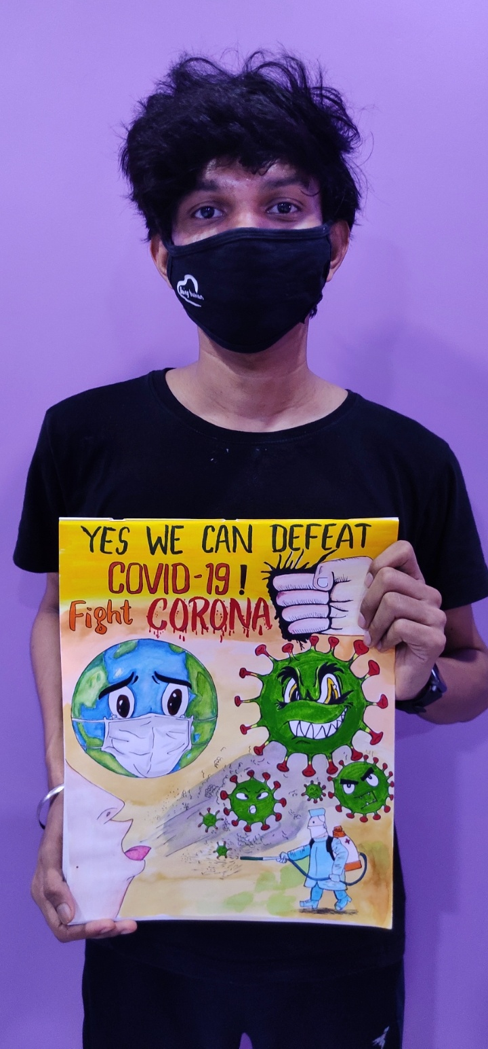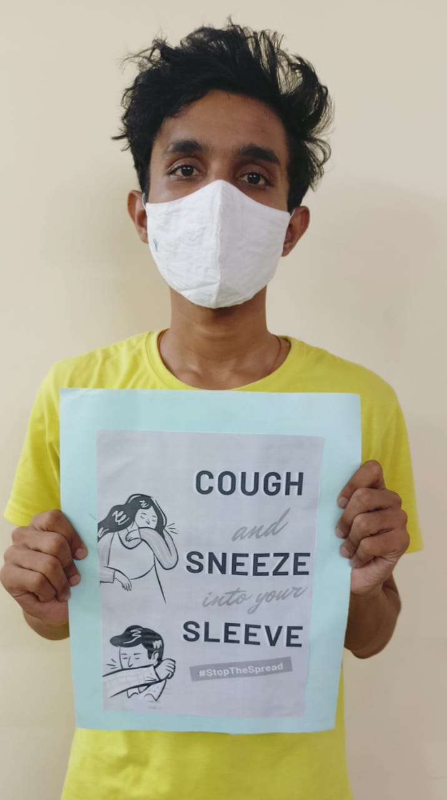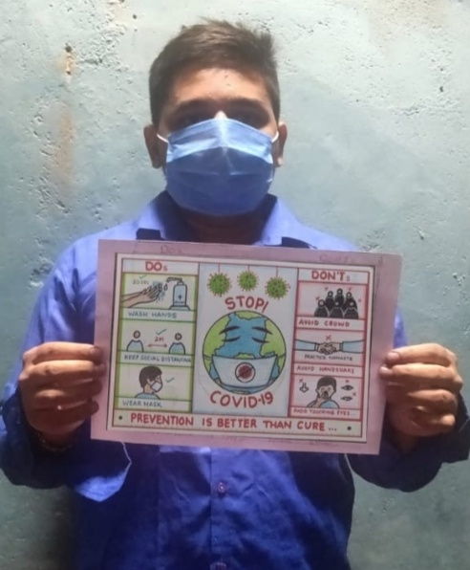

Overall Coordinator Department Coordinator

Dr. Chidananda.H